1. Actually mongodb uses BSON (Binary JSON) instead of json for storing data into the database.
2. You don’t care about this as you write and see json format.
3. There are a couple of reasons for storing BSON instead of JSON.
   1. It is more efficient from space and speed perspective.
   2. It supports some additional types.   
      There are different types of numbers such as decimal and some are really big and these are stored in different ways behind the scene. We don’t need to worry.
4. 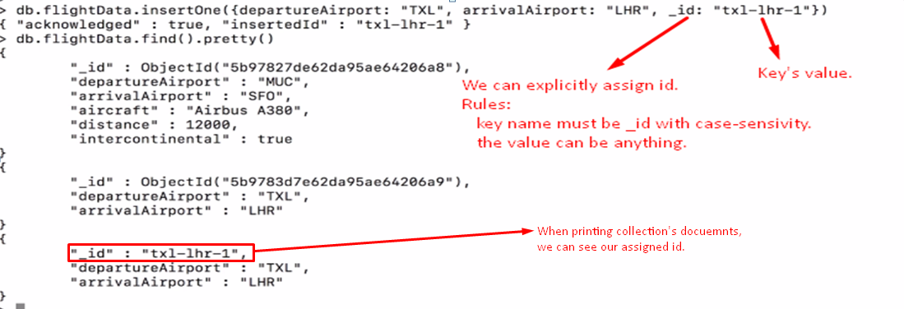
5. 